Creative Empowerment Opportunities

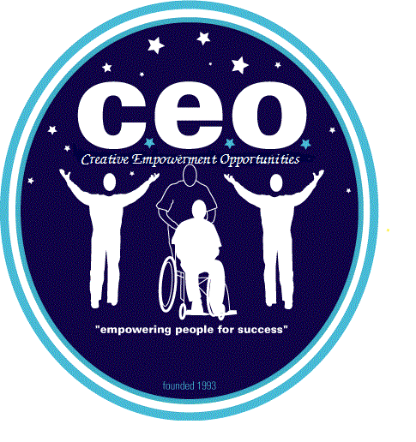

“Empowering People for Success”

MASTER CALENDAR

Program: Clinton TWP Group: C May/2025
MONDAY | TUESDAY | WEDENSDAY | THURSDAY | FRIDAY
 |  |  | 1 Anton Art Center   | 2 Location: BJ’S Budget  
5 Location: Henry Ford Museum   | 6 Location: Premier Bowling   | 7 Location: Focus Hope/St Matthias Church  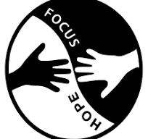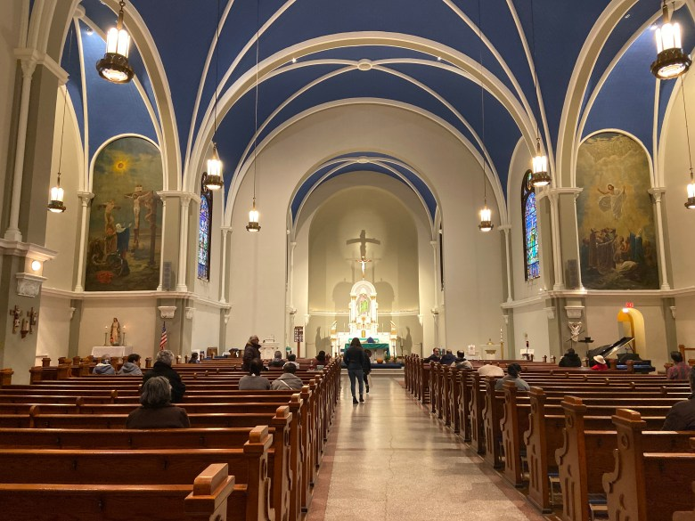 | 8 Location: St Clair Shores Library   | 9 Location: Macomb Mall  
12 Location: Light House Coffee   | 13 Location: MJR Chesterfield    This Photo by Unknown Author is licensed under CC BY | 14 Location: Focus Hope/St Matthias Church | 15 Location: George George Park  Exercise and Fitness Walk   | 16 Location: Henry Ford Museum
19 Location: Metro Beach  Exercise and Fitness Walk | 20 Location: Premier Bowling | 21 Location: Focus Hope/St Matthias Church | 22 Location: BJ’S Budget | 23 Location: St Clair Shores Library
26 Dodge Park  Exercise and Fitness Walk | 27 Location: MJR Chesterfield  This Photo by Unknown Author is licensed under CC BY | 28 Location: Focus Hope/St Matthias Church | 29 Location: St Clair Shores Library | 30 Location: Henry Ford Museum

Total cost for activities per person served: $_3 To 6_/person=$320=Total
**Any deviation/alternative activity must have prior management approval**
A Community Procedure Checklist must be filled out for any activity outside of the CEO-Community Empowerment Center
Job Exploration: defined as observing employment opportunities within the community
Volunteering: defined as performing non-paid job duties in the community at defined location where other people would normally volunteer. (Meals on Wheels, Metro Parks, 501 C3 organizations, Salvation Army, Arts & Scraps, etc.)
Micro-Business: defined as the development and the management of micro-business activity
Employment Skills: defined as the development of employment skills such as communication, following directions, time management, task completion, endurance and other skills required for employment.
Employment: defined as money making activities in the community.
Skill Development Activities: defined as one of the 12 skill building activities defined in the skill development list.
Definitions of Skill Development:
#1. Activities of Daily Living Skill Building: Teaching a Person Served skills in all basic areas of life. (examples: personal hygiene, cleaning, cooking, nutrition, safety, etc.)
#2 Functional Academics Skill Development: Teaching a Person Served all areas of academics that are present in function format and which are meaningful for the person.
#3 Social Skills Development: Teaching a Person Served self-control and etiquette through the use of gentle teaching and behavior modification.
#4 Recreation Skill Development: Teaching a Person Served how to engage in activities that bring feelings of leisure and fun. Types of recreational activities that are offered are community based (parks, shopping, OTE, movies, etc.), arts and crafts, table games, exercise, music, etc.
#5 Relaxation Skill Development: Teaching a Person Served how to relax their body response to stress. This will be supported by assisting in learning the relaxation response through use of quiet environment, calming music or rhythmic sounds, body relaxation and breathing exercises.
#6 Communication Skill Development: Teaching a Person Served ways to communicate their needs. Skills will be taught through the use of voice tone, sign language, picture boards, computer boards, etc.
#7 Horticulture Skills Development: Teaching a Person Served how to support and maintain plant life. This will be done with the utilization of our wheelchair accessible garden, which has raised gardening boxes in addition to shrubs, fruit trees and a vegetable garden.
#8 Technology Skill Development: Teaching a Person Served how to utilize a computer. Computers have been equipped with software to meet a multitude of cognitive levels.
#9 Sensory Integration Skill Building Development: Teaching a Person Served through their senses. The implementation of an occupational therapy evaluation could include the use of sounds, lights, textures, weighted vests, brushing, joint compressions, etc. All sensory integration programs are taught to the staff by funding agency’s Occupational Therapist.
#10 Pre-Vocational Skill Development: Teaching a Person Served the core skills needed for vocational skill development. Some areas of skill development taught are following directions, staying in the work area, correctly completing assigned job duties, etc.
#11 Vocational Skill Building: Teaching a Person Served the skills needed for supported employment. Some areas of skill development would be specific job duties related to the job, mobility training, dress code, personnel policies, etc.
#12 Physical Health Skill Development: Teaching a Person Served about the importance of maintaining physical health and offering individuals the information and techniques to participate in their own health care.

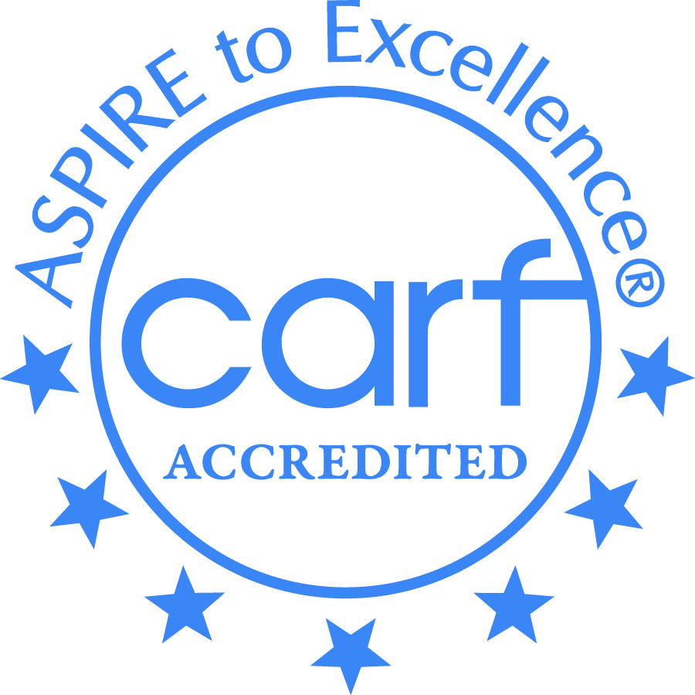

Revised 7/9/24 – Person Served: Master Community Calendar
Creative Employment Opportunities Inc. DBA Creative Empowerment Opportunities, a Michigan non-profit service corporation
and an equal opportunity at-will employer.

