Creative Empowerment Opportunities

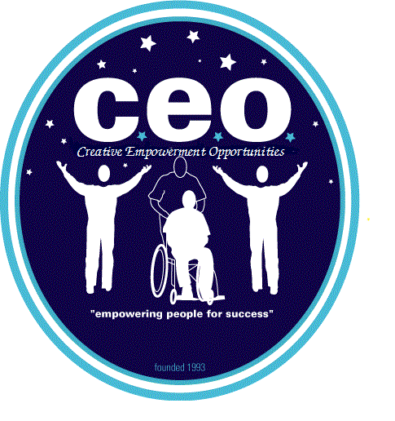

“Empowering People for Success”
Calendar CEO Anchorville
Program: CEO Anchorville Group A: Employment Month: April 2024
1) N/A | 2) N/A | 3) N/A | 4) N/A | 5) Location: 711  Focus: Employment  Skills: 1,2,3,6,10,11,12  Time: 9:30-2:00  Cost: n/a  PM: 711 Gratiot/ Hall
8) N/A | 9) N/A | 10) N/A | 11) N/A | 12) Location: 711  Focus: Employment  Skills: 1,2,3,6,10,11,12  Time: 9:30-2:00  Cost: n/a  PM: 711 Gratiot/ Hall
15) N/A | 16) N/A | 17) N/A | 18) N/A | 19) Location: 711  Focus: Employment  Skills: 1,2,3,6,10,11,12  Time: 9:30-2:00  Cost: n/a  PM: 711 Gratiot/ Hall
22) N/A | 23) N/A | 24) N/A | 25) N/A | 26) Location: 711  Focus: Employment  Skills: 1,2,3,6,10,11,12  Time: 9:30-2:00  Cost: n/a  PM: 711 Gratiot/ Hall
29) N/A | 30) N/A

Definitions of Skill Development:
Activities of Daily Living Skill Building: Teaching an individual skills in all basic areas of life. (examples: personal hygiene, cleaning, cooking, nutrition, safety, etc.)

Functional Academics Skill Development: Teaching an individual all areas of academics that are present in function format and which are meaningful for the person.

Social Skills Development: Teaching an individual self-control and etiquette through the use of gentle teaching and behavior modification.

Recreation Skill Development: Teaching an individual how to engage in activities that bring feelings of leisure and fun. Types of recreational activities that are offered are community based (parks, shopping, OTE, movies, etc.), arts and crafts, table games, exercise, music, etc.

Relaxation Skill Development: Teaching an individual how to relac their body response to stress. This will be supported by assisting in learning the relaxation response through use of quiet environment, claming music or rhythmic sounds, boday relaxation and breathing excersises.

Communication Skill Development: Teaching an individual ways to communicate their needs. Skills will be taught through the use of voice tone, sign language, picture boards, computer boards, etc.

Horticulture Skills Development: Teaching an individual how to support and maintain plent life. This will be done with the utilization of our wheelchair accessible garden, which has raised gardening boxes in addition to shrubs, fruit trees and a vegetable garden.

Technology Skill Development: Teaching an individual how to utilize a computer. Computers have been equipped with software to meet a multitude of cognitive levels.

Sensory Integration Skill Building Development: Teaching an individual through their senses. The implementation of an occupational therapy evaluation could include the use of sounds, lights, textures, weighted vests, brushing, joint compressions, etc. All sensory integration programs are taught to the staff by funding agency’s Occupational Therapist.

Pre-Vocational Skill Development: Teaching an individual the core skills needed for vocational skill development. Some areas of skill development taught are following directions, staying in the work area, correctly completing assigned job duties, etc.

Vocational Skill Building: Teaching an individual the skills needed for supported employment. Some areas of skill development would be specific job duties related to the job, mobility training, dress code, personnel policies, etc.

Physical Health Skill Development: Teaching an individual about the importance of maintaining physical health and offering individuals the information and techniques to participate in their own health care.
Key Terms:
AA: Alternative Activity PM: After Lunch Activity
Revised 3/15/21 BHC – Person Served: Macomb County Recipient Rights Contact Protocol 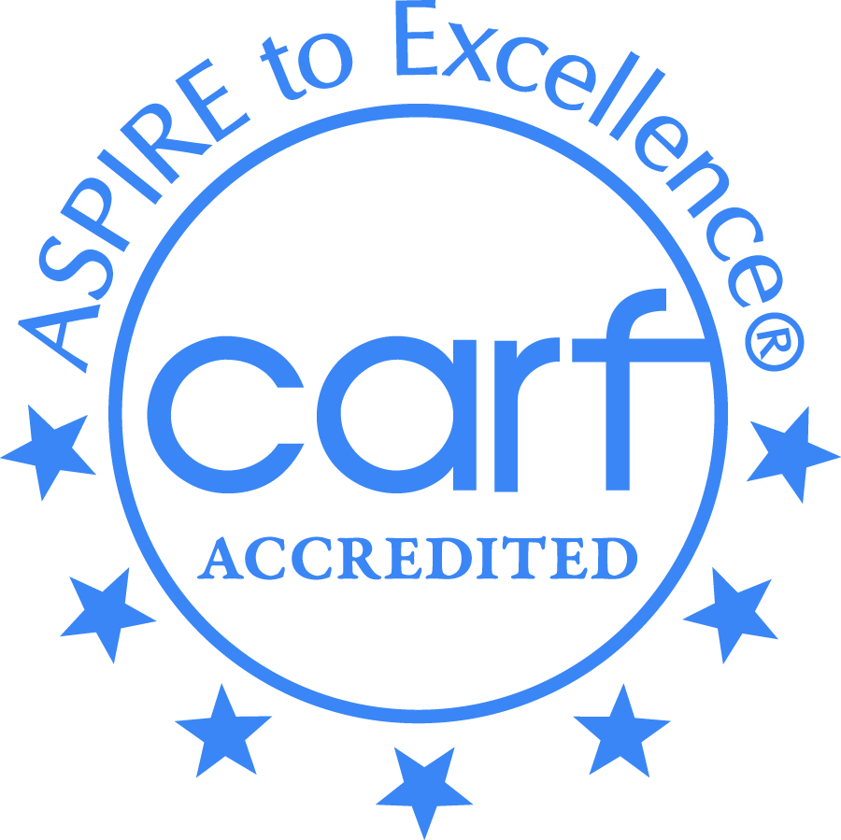
Creative Employment Opportunities Inc. DBA Creative Empowerment Opportunities, a Michigan non-profit service corporation and an equal opportunity at-will employer.

