



Creative Empowerment Opportunities

“Empowering People for Success”

## PROGRAM DESCRIPTION

**6615 N. Venoy, Westland**

**History**

Creative Employment Opportunities, Inc., DBA Creative Empowerment Opportunities (hereinafter referred to as CEO) was established on April 1st, 1993. We currently have5 locations in Macomb County, St. Clair County, Oakland County and Wayne County to proudly serve Persons Served with intellectual disabilities and those in recovery from mental illness. We focus on the 12 Core Skill Development areas during the service day. CEO is a CARF accredited organization. CARF is the Commission for Accreditation of Rehabilitative Facilities. The mission of CARF is to promote the quality, value, and optimal outcomes of services through a consultative accreditation process and continuous improvement services that center on enhancing the lives of the persons served.

Our Mission…We believe that all people are entitled to respect, dignity, independence, community integration and the opportunity to make choices in their futures.

**Persons Served**

Our Vision… “Empowering People for Success”. Our services are delivered in a Person First environment, embracing the culture of “Gentle Teaching”. We provide care and support to Persons with intellectual disabilities and those in recovery from mental illness. Our support team follows each Persons Served Individual Plan of Service to provide the necessary assistance and skills the Person is seeking. The Persons Served are encouraged to select meaningful goals to increase independence. We comply with the Home and Community Based Services and encourage community inclusion. The Persons Served has the opportunity to be a part of the monthly Person Served Advisory Committee that is run by and for the persons we support. A daily visual calendar of activities is posted in each center for Persons Served to be knowledgeable about their daily activities and assist with transition. A Monthly Communication Record is sent home with the Person to share their progress and goals obtained throughout the month. A monthly calendar of activities is created and is posted on our website [www.creativeempowerment.org](http://www.creativeempowerment.org).

**Employee Training**

Our support team is provided with many trainings that take place upon hire and annually. Before an employee is hired, we conduct background checks which include a criminal history, sex offence registry, driver’s license check and a Recipient Rights check. All new employees receive policy and procedure training, First Aid, CPR, Gentle Teaching and Non-violent Crisis Intervention prior to working with the Persons we serve. Employees will receive training through the Office of Recipient Rights and additional training through our funding agencies.

**Safety Information**

A First Aid Station is at all CEO locations. The station will contain items needed to ensure Universal Precautions.

The medication cabinet and all supplies necessary are kept in a locked cabinet. This is also the area for a Person Served

to relax if not feeling well or exhibiting communicable illness. The Safety Data Sheets (SDS) will also be located at or

near this station. All information, ingredients and precautions for all products used in the building will be found in the

SDS book. Employees receive training on dispensing medications and providing basic first aid.

**Selecting Community Empowerment Service**

Persons seeking services from CEO can start the process by receiving services from your local Community Health agency. The Community Health agency will assign a Support Coordinator to develop a Person Plan of Service with goals that are medically necessary. Upon selecting CEO services, a meeting with the Person Served and their support team will take place at the Community Empowerment service location selected. The Support Coordinator will then authorize the services that the Person will receive at the designated Community Empowerment Center. Once CEO receives the Authorization, a phone call will be made to the Persons home letting them know when they can start and the time of pick up if transportation is included in the Authorization. In the event the Authorization is denied, the Person may Private Pay for the service(s) they are seeking.

**Menu of Services**

**Community Empowerment Center** –

This program is for Persons Served who needs to improve adaptive skills. Services are provided in a classroom setting, with a structured lesson plan focusing on the 12 Core Skill Development areas. Skills addressed are Activities of Daily Living, Functional Academics, Social Skills, Recreational Skills, Relaxation, Communication, Horticulture, Technology, Sensory Integration, Pre-Vocational Skills, Vocational Skills and Physical Health. Persons interested in gaining employment skills can focus on work preparatory, aimed at preparing for paid or unpaid employment, not job task-oriented. They will work on specific areas that the Person may need additional support. Essential barriers to future employment are addressed and abilities strengthened.

**Enhanced Staffing** – May be available once the need has been established per the Person’s Plan of Service and the funding agency has approved the authorization. The Persons Served will then have an in-serviced Direct Supports Professional assigned to work only with them. The Person Served may select any one of the services offered. This service may also be authorized for community employment.

### **Volunteering** – The Person’s Served receive Skill Building assistance in area’s defined in their Individual Plan of Service. This service will benefit Persons who might need improvement in areas of; self-help, socialization. This is an opportunity for the Persons Served to “give back” to the community by providing an unpaid work experience to develop key skills needed for employment. An agreement will be made with the establishments prior to beginning volunteering. Volunteer sites are located in the communities near the CEO locations and are considered acceptable by the Department of Labor.

**Greater Community Empowerment Services –** Providing integrated community experiences to reinforce skills that are

not job task-oriented. Some concepts learned may consist of improving safety skills, task completion, problem solving,

money management, communication, mobility, etc.

**Supported Employment Program** – Our Job Development Team work directly with Michigan Rehabilitation Services and Persons Served who have demonstrated sufficient adaptive and vocational skills that are interested in community employment. Once an assessment has been completed with the Person Served and an employment site has been established an authorization approval is needed by the funding agency for the Person Served to be provided a Direct Supports Professional to assist with specific job training and emotional support, also to act as a liaison between the Persons Served, Coworkers, and Management. Direct Supports Professionals will ensure all workplace rules are known, understood, and followed; and monitor for any safety concerns.

**Micro-Enterprise Opportunities-** This program is designed for Persons who have demonstrated good work skills and have developed an idea for a small business that they can operate independently. These Persons Served develop a business plan (with the assistance of staff), run the business, and receive compensation from business profits. Some examples of current micro-business projects are; Selling crafts and other products made by Persons Served, selling pop and/or snacks, horticulture – growing and selling fruits & vegetables etc. Participants are encouraged to be as independent in their self-employment as possible, but are given staff support as needed.

**Transportation –** CEO provides primary and/or secondary transportation at most facilities. Primary transportation is designed to transport Persons Served between their homes and their selected service sites. Secondary transportation is that which transports Persons Served from a CEO Service site to a job site, or community activity and back to CEO. Transportation is provided in well-maintained vehicles. Each vehicle in the fleet is clearly marked on the back door with CEO LOGO and phone number. Transportation is an additional service that can be addressed during the intake process.

**Program Information**

**Empowerment Center Name:** Westland **Program Supervisor:** Ron Peguies

**Address:** 6615 N. Venoy **City:** Westland **State:** MI **Zip:** 48185 **Phone:** 734-727-0872

|  |  |  |  |
| --- | --- | --- | --- |
| **SERVICE** | **YES** | **NO** | **DESCRIPTION OF SERVICE** |
| Transportation: Ambulatory | X |  | Will transport Persons Served who are living at home with their families and who are in close proximity to the Empowerment Center. |
| Transportation: Non-Ambulatory | X |  | Will transport Persons Served who are living at home with their families and who are in close proximity to the Empowerment Center. |
| Community Empowerment Academy |  | X |  |
| Community Integration | X |  | Volunteering, Employment, Skill Development |
| Skill Building Classrooms | X |  | Structured skill building development for those Persons that may choose facility based learning, |
| Micro-Business/Contract Work | X |  | Micro-business work available for Persons who wishes to earn money through their own business by selling various products. |
| Visual Communication | X |  | Visual Communication available through the use of pictures and symbols on our communication board. |
| Gym |  | X |  |
| Library | X |  | Books, magazines and a quiet area available for Persons. |
| Social Recreation Center | X |  | There are social areas of the Empowerment Center where socialization can be utilized by our Persons. |
| Computer Lab | X |  | Several computers are set up in rear of the big classroom for our Persons. |
| Exercise Center | X |  | We have several pieces of exercise equipment that can be utilize by our Persons and or the public any time during business hours. |
| Art Center | X |  | We have an art room that is utilized daily with various activities available. |
| Relaxation Center | X |  | Our front lobby has comfortable furniture and can be a quiet relaxing place during most of the day before and after change over. |
| Kitchen | X |  | Full kitchen available for cooking and baking classes. |
| Horticultural | X |  | Horticultural skills are provided by visiting our local nurseries and gardening center, teaching and learning the different types of outdoor plants. |
| Green Space | X |  | Westland Empowerment sits on 3 1/12 acres of beautifully manicured land with plenty of tress at the rear that provides shade. Great location to be out doors. |
| Pet Therapy | X |  | Visits the Michigan Humane Society and pet store |
| Wheelchair Accessible | X |  | Westland Empowerment Center is totally wheelchair accessible |
| Personal Care | X |  | Persons Served are taught and or encouraged to use personal care skills |
| Enhanced Staffing | X |  | Once the need has been established per the plan of service. |

###### Map to the Westland Location:

### 6615 N. Venoy

Westland, MI 48185

Phone: (734) 727-0872 FAX: (734) 727-0873

Program Supervisor: Ron Peguies

[**www.creativeempowerment.org**](http://www.creativeempowerment.org)



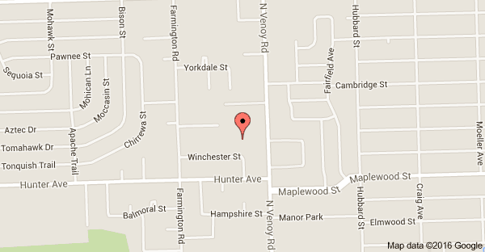

##### 

**Creative Empowerment Opportunities**

**“Empowering People for Success”**

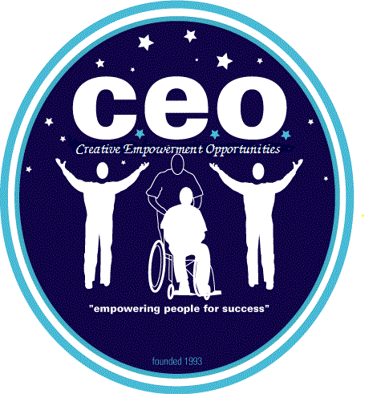

**Westland**

**Community Empowerment**

**Center**

Description

Revised 7/2022, 3/2021

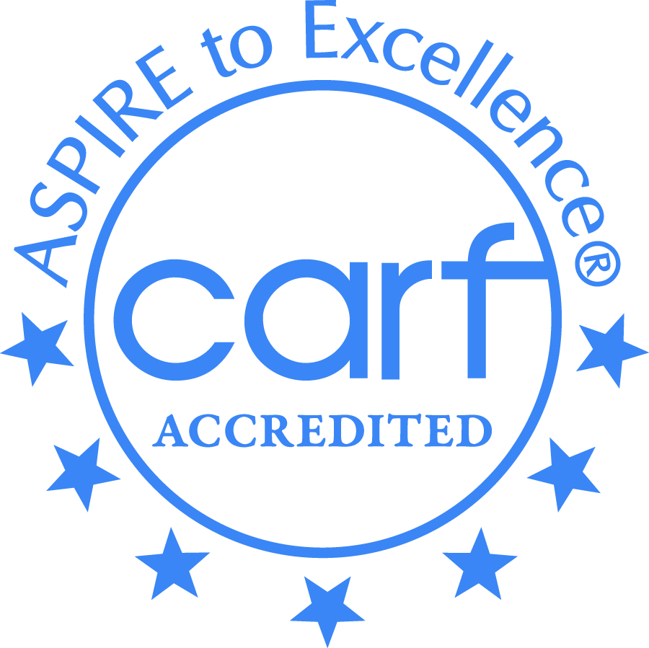

Creative Employment Opportunities Inc. DBA Creative Empowerment Opportunities, a Michigan non-profit service corporation and an equal opportunity at-will employer.

