Creative Empowerment Opportunities
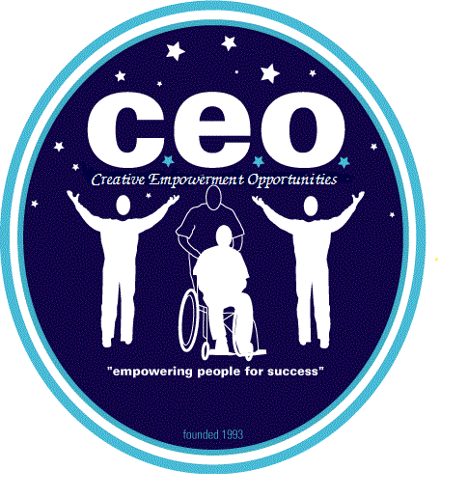
2020 ANNUAL REPORT

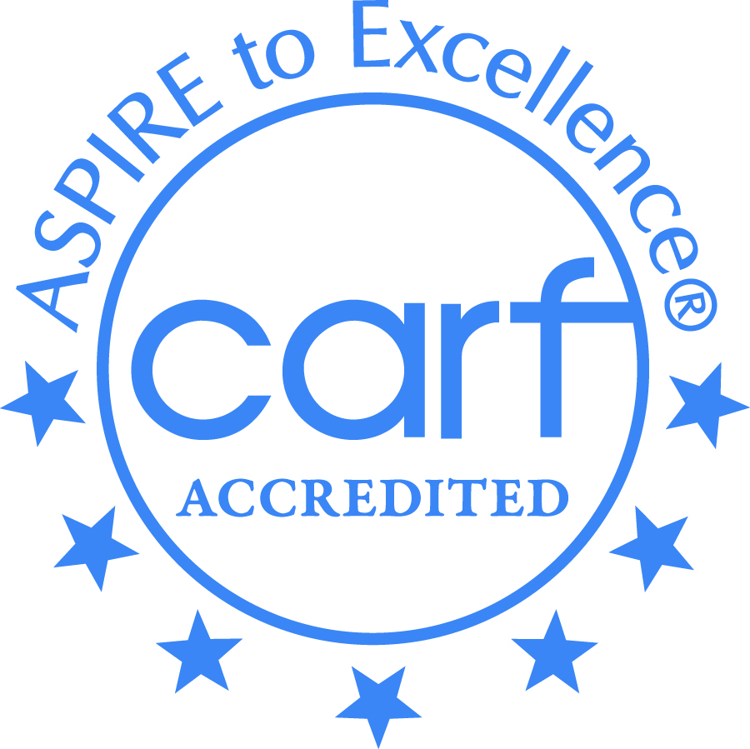

Creative Employment Opportunities Inc. DBA Creative Empowerment Opportunities, a Michigan non-profit service corporation
and an equal opportunity at-will employer.

ABOUT US
Creative Empowerment Opportunities began as a small non-profit human service agency servicing a few Persons Served in Macomb County, Michigan. Creative Empowerment Opportunities helps Persons Served learn daily living skills in functional academics, physical health, social recreation, volunteering, and employment. We serve Wayne, Oakland, Macomb and St. Clair Counties and offer transportation services. We have been providing supports for Persons Served with intellectual disabilities, autism spectrum disorders, physically challenged and persons in recovery from mental illness since 1993.

Prior to the COVID-19 Pandemic, CEO had grown to 8 locations and proudly served over 500 persons served with 150 employees. Once the pandemic was declared, our services were forced to discontinue until safety plans and procedures could be revised and safety measures could be implemented, and the quarantine lifted.

MISSION STATEMENT
We believe that all people are entitled to respect, dignity, independence, community integration, and the opportunity to make choices in their own future.
December 2012

VALUES
- Creative Empowerment Opportunities, values and respects the ability of all individuals to make choices within their person-centered plan.
- Creative Empowerment Opportunities, values the development of pro-active and productive relationships with stakeholders.
- Creative Empowerment Opportunities values maintaining safe environments to promote the skill development of individuals served.
- Creative Empowerment Opportunities values the principals and practices of Gentle Teaching.
- Creative Empowerment Opportunities, values promoting a service selection of community employment, community-based skill development, community living skills, community volunteering and transportation services.
- Creative Empowerment Opportunities, values the staff and supports their individual growth to enhance services to individuals served.

HIGHLIGHTS FOR 2020
- Successfully re-opened on August 23, 2020 after closure on March 16th, 2020 due to the COVID-19 Pandemic.
- Implemented a wide variety of infection control measures and acquired equipment to help reduce spread of infection both in the vehicles and in the Community Empowerment Center.
- Developed a comprehensive COVID-19 training for employees.
- Developed a thorough COVID-19 Response plan approved by the Michigan Department of Health & Human Services, the Center for Medicaid Services, the Infection Prevention Resource and Assessment Team and the Oakland County Health Department.
- Purchased Henry Ford Museum and Greenfield Village passes.
- Financial department was able to convert all employee pay stubs to electronic pay stubs.
- Successfully revised all forms and policies updating term “individual served” to “persons served” and “SBI/Skill Building Instructor” to “DSP/Direct Supports Professional”.

- Creative Empowerment Opportunities- Anchorville:
- Hosted a “Beat the Winter Blues” party.
- Started an attendance raffle as persons served recognition program.
- Volunteered for Meals on Wheels, Focus Hope and several local churches.

- Creative Empowerment Opportunities-Clinton Township:
- Received a donation of games for game club.
- Volunteered at several local churches.
- Re-structure the Employment Development Team.

- Creative Empowerment Opportunities-Madison Heights:
- All services are 100% community based.
- Developed 2 new volunteer sites at Meals on Wheels.
- Developed a portable snoezellen kit
- Upgrade travelling lunch kits.

- Creative Empowerment Opportunities-Mt. Clemens:
- Obtained a new Wii system with controllers
- Rebuild wall/interior after property damage occurred.

- Creative Empowerment Opportunities-Pontiac:
- Added a split rail fence to the front part of the property.
- Installed sliding document holders in the bathrooms.
- Developed a Meals on Wheels volunteer site.
- Developed an organized storage of spare clothing.

- Creative Empowerment Opportunities- Washington:
- Began volunteering for Meals on Wheels in their community.
- Painted the conference room and classrooms.
- Added a new van to the fleet
- Developed an off-site baking class.

- Creative Empowerment Opportunities-Westland:
- Hosted annual Halloween Party
- Hosted annual Thanksgiving feast.
- Hosted annual Christmas dinner.

- Creative Empowerment Opportunities-Detroit:
- Maintain the property during the down-time created by the COVID-19 pandemic.

PROGRAM SERVICE SELECTIONS
Our services are offered in Macomb, Oakland, St. Clair and Wayne Counties. Persons Served select a program according to their desires, skills, abilities, and the recommendations of the Person Centered Planning Team.
Service Programs which may be Selected are:
- Community Centered Based Adaptive Skill Building
- Greater Community Based Adaptive Skill Building
- Community Centered Vocational Skill Building
- Supported Employment
- Community Living Supports
- Transportation

PERSON SERVED FEEDBACK SURVEY RESULTS
- 99% of Persons Served satisfied and happy at Creative Empowerment Opportunities.
- 98% of Persons Served are happy with their daily activities.
- 99% of Persons Served feel they are given choices in their daily activities.
- 100% of Person Served feel safe at C.E.O. and/or at their work site.
- 99% of Persons Served feel their Direct Supports Professionals treat them well.
- 99% of Persons Served understand the work rules.
- 99% of Persons Served have friends here at C.E.O. or at your job.
- 99% of Persons Served feel they are able to contribute to and discuss things at Person Centered Planning meetings?
- 99% of Persons Served feel that the staff at CEO respect their diversity related needs.

2020 EXPENDITURE BREAKDOWN

CREATIVE EMPOWERMENT OPPORTUNITIES FUNDING SOURCES
- Community Living Services
- Detroit/Wayne Integrated Health Authority
- Michigan Department of Health and Human Services
- Macomb County Community Mental Health
- MORC, Inc.
- Oakland County Health Network
- Private Pay

SERVICE SITES
- CEO :Anchorville – 9974 Dixie Hwy, Ira Twp
- CEO :Clinton Township – 34820 Harper Ave., Clinton Twp.
- CEO: Detroit– 9245 Mack, Detroit
- CEO Madison Heights-345 Edison, Pontiac
- CEO :Mt.Clemens – 308 North Gratiot, Mt Clemens
- CEO :Pontiac – 345 Edison, Pontiac
- CEO:Washington-59027 Van Dyke, Washington
- CEO :Westland – 6615 Venoy, Westland

VOLUNTEER SITES
- Local Churches
- Focus Hope
- Meals on Wheels
- Local Parks
- Madison Heights Active Adult Center
- Baldwin Center
- Woodside Bible

COMMUNITY INTEGRATION

- Libraries
- Detroit Science Center
- Detroit Zoo
- Nature Centers/Conservatory
- Aquarium
- Dairy Farm
- Malls/ Movies
- Sporting Events
- Local Parks
- Cider Mills
- Nurseries
- Animal Shelters/Pet Stores
- Museums & Art Galleries
- Karaoke
- Billiards
- Fishing
- Bowling
- Detroit Institute of Arts
- Gleaners Food Bank
- Empowerment Academies
- Tours of local businesses including fire department, Morley’s candy factory, etc.

Future C.E.O. Initiatives for 2021
- Develop Telehealth program to accommodate persons served who are unable to safely resume in-person services due to the COVID-19 Pandemic, receive skill development services from home.
- Create a CEO newsletter for stakeholders which will highlight informative topics such as specific protocols/procedures, new events, programs, services, milestones, etc. quarterly.
- Revise and enhance the Employee Incentive & Retention Policy to include new/increased referral bonsuses, hire-on bonuses and other incentive programs.
- Develop an Employee Wellness program to provide employees with coping tools, strategies and encouragement when experiencing the on-going stressors of the COVID-19 pandemic.
- Increase return of persons served by 50%.

“Empowering People for Success”

