3/16/20

*Dear (Person Served),*

*You are being contacted today with important information about a temporary change in the services you receive at skill-building. In support of Governor Whitmer’s executive order to reduce the spread of Coronavirus (COVID-19) by asking people to avoid large gatherings, we must all do our part to promote the safety of our community. This includes some services being discontinued for a short period of time.*

*We are very understanding of the stress these changes in service may cause for you or your loved one, and view these measures as absolutely necessary in order for us to move past COVID-19 and back to our daily routines.*

*If you have any additional questions or concerns, please contact OCHN’s Customer Services through our website at www.oaklandchn.org using the Contact Us Link. You can also reach them by phone 248.464.6363. If you are experience urgent anxiety about these changes and COVID-19, please call the Crisis Helpline at 800.231.1127. A link connecting to Oakland County’s Heald Divisions COVID-19 resource page is also located on the top banner of our website.*

*If you have any questions for Creative Empowerment Opportunities please feel free to call the location you attend, management will be checking messages & emails.*

*Thank You,*

*Creative Empowerment Opportunities*

*Kathleen Kunz-Pielack*

*Executive Director*

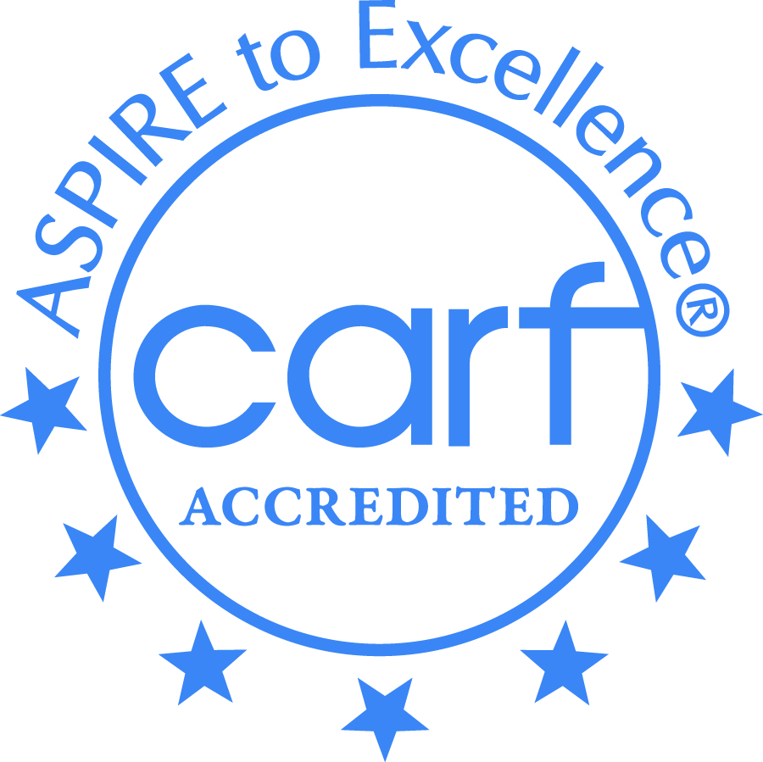

Creative Employment Opportunities Inc. DBA Creative Empowerment Opportunities, a Michigan non-profit service corporation and an equal opportunity at-will employer.

**Creative**

**Empowerment**

**Opportunities**



“Empowering People

For Success”

**Administrative Offices**

*CEO Clinton Twp.

34820 Harper Ave.

Clinton Twp. MI 48035

586-569-4250

Fax 586-569-4258

*CEO Anchorville

9974 Dixie Hwy.

Anchorville, MI 48004

586-716-9920

Fax 586-716-9928

CEO Madison Heights

Community Based Program

248-259-1842

*CEO Mt. Clemens

308 N. Gratiot

Mt. Clemens, MI 48043

586-493-9715

Fax 586-493-9717

*CEO Pontiac

345 Edison St.

Pontiac, MI 48342

248-858-7847

Fax 248-874-0036

*CEO Washington

59027 Van Dyke Ave.

Washington Twp., MI 48094

586-935-1500

Fax 586-232-4875

*CEO Westland

6615 N. Venoy

Westland, MI 48185

734-727-0872

Fax 734-727-3514

*Empowerment Centers