March 14th, 2020

To: Person Served, Guardians, Families & Home Placement Staff

Creative Empowerment Opportunities programs will be closed with a tentative date of re-opening on April 6th, 2020.

The decision to temporarily close has been given by the Michigan Department of Health and Human Services in order to avoid the spread of the coronavirus.

Please continue to follow proper personal hygiene measures to prevent the spread of the virus.

* Wash hands often with soap and water
* Avoid touching your face with unwashed hands
* Cover your mouth and nose with a tissue when coughing or sneezing
* Avoid handshakes
* Avoid contact with sick people
* Stay home if you are sick

The letter from Community Mental Health has been attached to our website for further reference [www.creativeempowerment.org](http://www.creativeempowerment.org)

The following website contains additional information regarding the virus [www.michigan.gov/coronavirus](http://www.michigan.gov/coronavirus)

We will forward any further information as it is provided.

Thank you

CEO Management

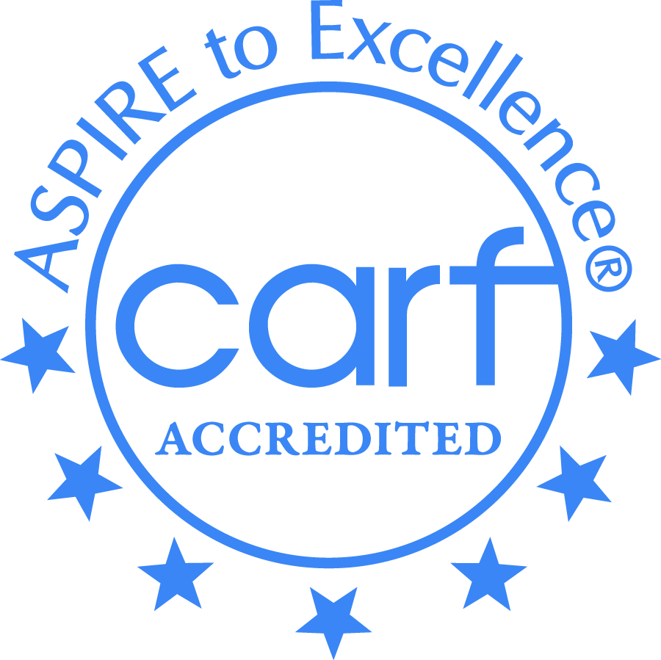

Creative Employment Opportunities Inc. DBA Creative Empowerment Opportunities, a Michigan non-profit service corporation and an equal opportunity at-will employer.

**Creative**

**Empowerment**

**Opportunities**

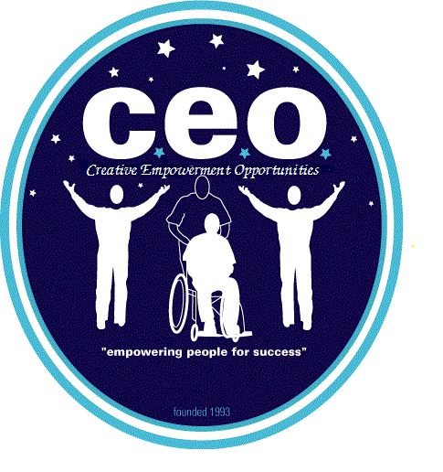

“Empowering People

For Success”

**Administrative Offices**

*CEO Clinton Twp.

34820 Harper Ave.

Clinton Twp. MI 48035

586-569-4250

Fax 586-569-4258

*CEO Anchorville

9974 Dixie Hwy.

Anchorville, MI 48004

586-716-9920

Fax 586-716-9928

CEO Madison Heights

Community Based Program

248-259-1842

*CEO Mt. Clemens

308 N. Gratiot

Mt. Clemens, MI 48043

586-493-9715

Fax 586-493-9717

*CEO Pontiac

345 Edison St.

Pontiac, MI 48342

248-858-7847

Fax 248-874-0036

*CEO Washington

59027 Van Dyke Ave.

Washington Twp., MI 48094

586-935-1500

Fax 586-591-5944

*CEO Westland

6615 N. Venoy

Westland, MI 48185

734-727-0872

Fax 734-727-3514

*Empowerment Centers